HAMPDEN COMMON FORAY

October 29th pm. Leader Tony Marshall
Penny Cullington

Three of us met up for the afternoon session today in the hope of finding good waxcaps on the cricket pitch. We collected and identified 11 different species in a good array of reds, yellows, greens and whites, and also a more unusual brown one with the imaginative name Hygrocybe fornicata - it’s always a delight to see these brightly coloured little gems and it was a relief to find that the recent rain had spurred at least some fruiting in the grassland into action, though the surrounding woodland was pretty barren of fungi. Also plentiful in the mossy grass was a good selection of fairy clubs, and looking at spores later revealed four different varieties of yellow Clavulinopsis.

The most exciting find in the woodland was the bright mustard-coloured arachnoid spread of the plasmodium of a slime mould clearly in the process of ‘moving’ along a Larch stick. This I had to collect to see what it might turn into, and the following morning it had travelled along the stick and partly onto the grass beside it and the individual fruitbodies of Leocarpus fragilis were now recognisable. See the photos below.

See the complete list of species for details.

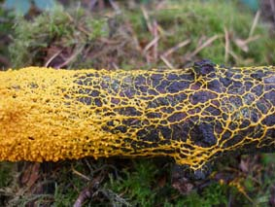
The plasmodium (slime) stage of Lecocarpus fragilis as it spreads along a stick in search of nutrients before settling down to mature and develop spores. (Photo by Penny Cullington)

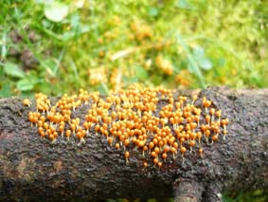
The same specimen the next morning having spread partly onto the grass and now developing stalks and heads full of maturing spores. (Photo by Penny Cullington)

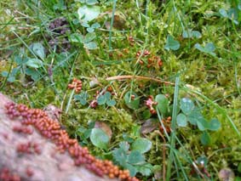
The same specimen on the third morning now approaching maturity and showing clusters of the typical red-brown fruitbodies looking a bit like a bunch of dates. (Photo by Penny Cullington)

