Joint BFG / Oxfordshire Fungus Survey FORAY at Wotton Park Estate, Sept 4th 2011
Penny Cullington

Luckily this foray was an afternoon event as the torrential and persistent morning rain had passed through and the eleven attendees enjoyed the warm sunshine and beautiful lakeside views as well as the fungi. This site always provides interesting species, and today was no exception despite the dry conditions of the previous week (the latest rain being too recent to affect fruiting).

We recorded just under 50 species, and Alan Hills was particularly pleased that some good boletes turned up, with a couple of specimens of Boletus satanas, a few more of Boletus radicans, and even more of Boletus luridus – all species we have found here before. However, Leccinum duriusculum was new to the site, a species which grows exclusively with Poplar (which abounds here) and which has blackening stipe flesh which helps to separate it from other similar Leccinum species. Mycorrhizal species –other than the boletes – were in very short supply, with no Amanita, Lactarius, Inocybe, Cortinarius or Hebeloma and only a couple of Russula species, both of which resisted identification. Bolbitius reticulatus was a nice find, as was Coprinellus saccharinus – a species added to the British Checklist on the basis of a record from this site in 2008 (it was previously rejected as being “dubiously distinct from Coprinellus truncorum” – another species found during the present foray). Perhaps the highlight was a beautiful collection of Lentinus tigrinus which Joanna found in the long grass down by the lake, no doubt growing on submerged rotting wood. This was also new to the site. See the photo below.

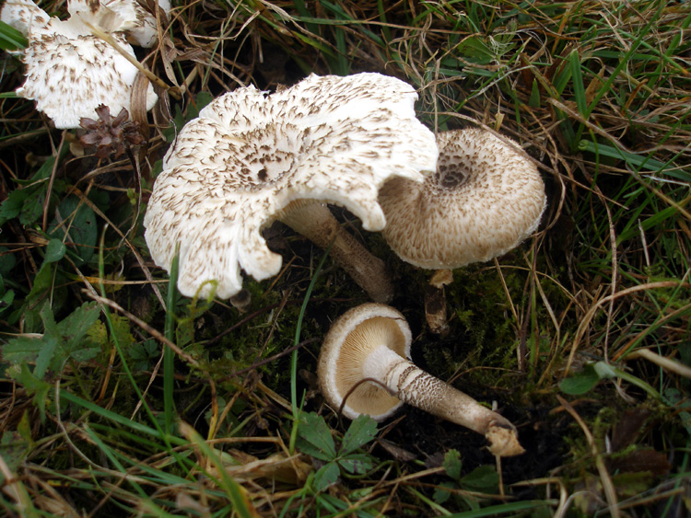
Lentinus tigrinus, an uncommon species which occurs typically in flood plains or near water on the wood of Willow or Poplar. The stipe markings are a very distinctive feature as the name ‘tigrinus’ implies. Photo Penny Cullington

