Mousells Wood Foray

Joint BFG / Frieth Natural History Society, Sunday, October 2nd. Leader Geoffrey Kibby.

Penny Cullington

After the exceptionally warm and dry period leading up to this event, when most of the Chiltern woodland had become rather frizzled and unproductive during the previous week, I had my fingers crossed that this privately owned piece of ancient woodland dominated by mature Beech and on a sheltered north-facing slope might have retained enough moisture to provide us with an enjoyable foray. We were not disappointed. A group of about 15 of us (though only four BFG members – the only disappointment) spent a very good morning with some really exciting things turning up as is often the case here. This site continues to produce rarities and prove its worth as a regular on our foray programme.

We recorded 118 species, of which about 30 were new to the site - though this in itself is not necessarily significant as records for the wood only started in 2005 when we were first invited here, with our foray this year being just the sixth visit of any significance by recognised mycologists. Sadly the large and impressive Cortinarius species of the Phlegmacium group (for which the wood is developing quite a reputation) were not on show, but there were plenty of other specialities of the site in good numbers. The genus Inocybe (Fibrecap) was well represented (not unusual here) with over ten different species, one of which we also found here last year and are still working on as it might possibly be new to Britain. However, the brightly coloured genus Russula (Brittlegill) took centre stage with fifteen different species found, this being fortuitous as our guest leader happens to be the country’s expert on this beautiful and challenging group, and some of our finds were of things very seldom recorded. Of particular note were Russula decipiens, faginea (see photo below), farinipes, grata, puellula, romellii and solaris, all of which are species of calcareous soil and grow in association with Beech. Also well represented was the closely related genus Lactarius (Milkcap), and of the six different species Lactarius ruginosus was a special find with only one previous county record. Both boletes and Amanitas were extremely thin on the ground, though Steve and Margaret Kelly who continued foraying into the afternoon, found Amanita echinocephala and phalloides together with the rare Rhodotus palmatus and Calocybe ionides, adding four species new both to the list for the day and for the site. We finished off our morning by finding two very convincing fruitbodies of the rare puffball Lycoperdon echinatum, a species we found here also in 2005 and always a nice thing to see.

I would encourage members, especially those who live in the southern half of the county, to make a note of future forays here. Every time we visit we are rewarded with surprising numbers of fungi even in dry conditions thanks to the position of the site. All who attended thoroughly enjoyed the morning and benefited especially from the enthusiasm and expertise of our excellent guest leader. Thank you, Geoffrey; we now know more about the fungal flora of this wood and all learnt a great deal, beginners and old hands alike.

See the complete list of species for more details.

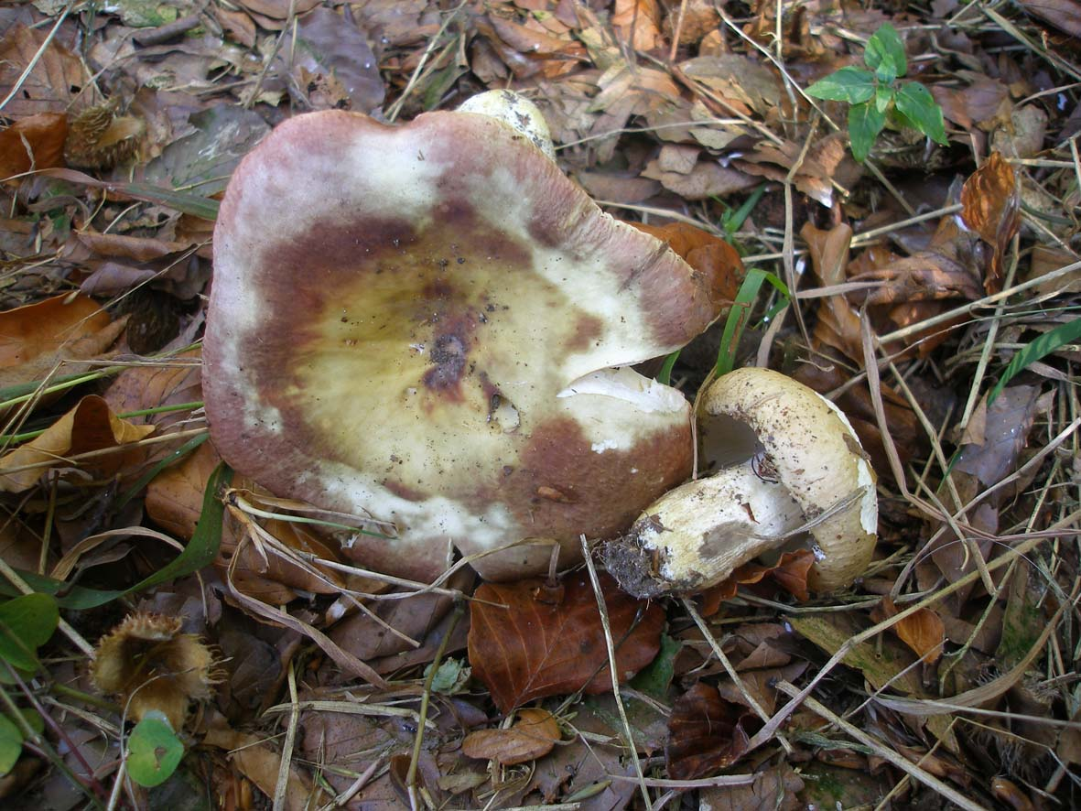

Russula faginea, a rare mushroom of the Xerampelina group of Brittlegills which smell of crab / fishy and have a stipe that stains dark green rather than the normal dirty orange when rubbed by a crystal of Iron salts (just visible on the smaller specimen in the photo). The larger specimen was over 10 cms across, not unusual for this species which is found only in mature Beech woodland on calcareous soil. Photo Penny Cullington.

