Carpenters Wood Foray

Joint BFG / HBFG Foray on Sunday, January 15th. Leader Penny Cullington.

Our first foray of the year proved yet again how worthwhile it is taking a good look for fungi out of the official main season, despite the fact that the previous night’s hard frost did its best to make things difficult. Our keen and hardy group of 15, no less, were not deterred by the chilly conditions and were rewarded by bright sunshine throughout. We produced a list of over 50 species – mostly fairly predictable and common things, but by no means all. 20 gilled fungi were found, though many were only singletons, but still making a good number for this time of year.

The gilled species we found in most profusion and which proved the most interesting was new to all but Derek, and had by chance just been brought to the notice of Field Mycology readers in an article by past member Nick Legon in the latest issue just out. (See FM 13(1) page 3 for more info.) We found in the frozen but rotting deciduous leaf litter several groups, some clustered, of an innocuous olive-brown mushroom having a whitish margin and reminding somewhat of the very common Collybia butyracea (Buttercap) in stature, cap texture and colour, but clearly different underneath owing to cocoa-brown spores and a cylindrical palish stipe (not swollen with a reddish tinge as in that species) and having signs of a ring zone also. The penny dropped (forgive the pun!) with both Derek and I, having just read our copies from cover to cover, though the new name quoted by Nick for this little known but not necessarily rare species eluded us. We managed to recall one of its many older names, Pholiota oedipus, and later Derek confirmed at home that this was indeed that species though now known as Meottomyces dissimulans. This very ordinary-looking wintertime fungus boasts no less than 11 previous names having been placed in nearly as many different genera at one time or another dating back to its discovery in 1882. Clearly a misfit, it now has the privilege of residing in a genus of its own, and is well worth looking out for on winter woodland walks.

Amongst several things that Steve found was a cluster of what looked like an unusually large slime mould on bark – so large that I struggled to believe it was one. This is always a good site for myxos – we found two others as well – but I’d never seen one with fruitbodies standing 1 cm high and looking at first glance more like some greyish-capped tiny Mycenas. Derek recalled some fungus which looked exactly like a myxo but in fact wasn’t one, but when I worked on it at home so many features seemed to fit with the myxo genus Didymium, and as I failed to trace anything else it could be I decided to send a photo (see below) and description to guru Bruce Ing.

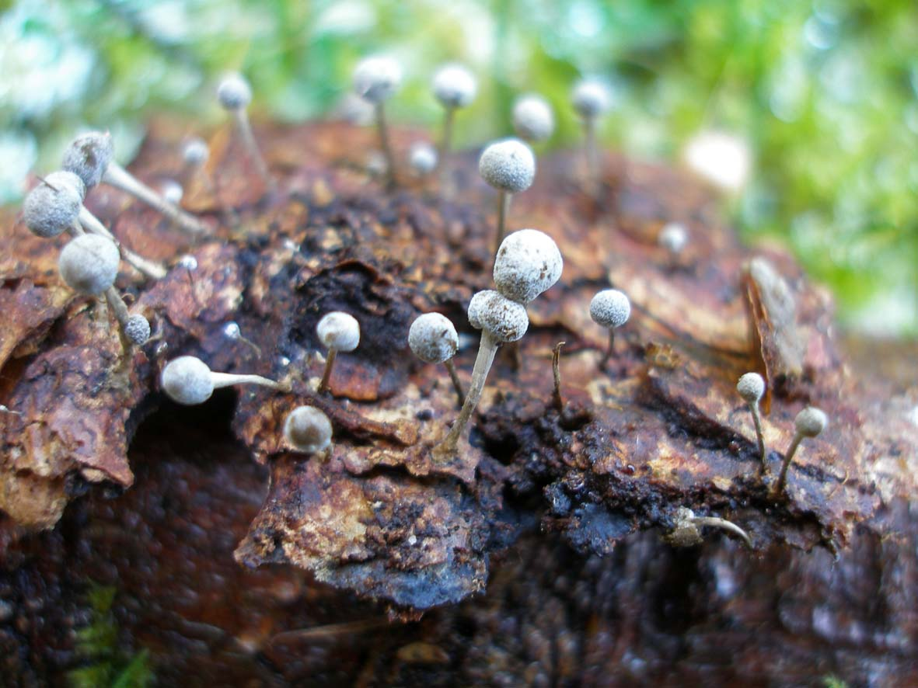

Phleogena faginea, an unusual species collected on our foray at Carpenters Wood by Steve Kelly, looking very like a slime mould but in fact related to the rusts. The fruitbodies are only 1 cm high.

He identified it straight away as Phleogena faginea. This is as I had initially suspected not a slime mould though an amazing look-alike of one, but related to the rusts, actually being a Basidiomycete – as are gilled fungi. The give-away differences are its size and the fact that under the scope there are clamps present, a feature I’d spotted and that had indeed worried me.

The two species featured above alone made the foray worthwhile, and we all learnt something new. My thanks to Bruce for his help.

See the complete list of species for more details.

